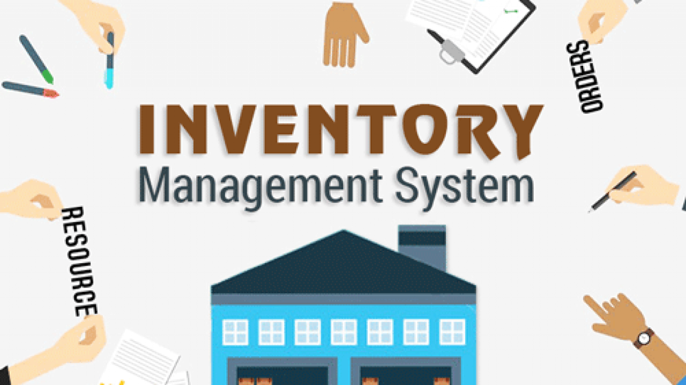

Inventory Management System Final Project report

MIS-64011-002 systems simulation

Dr. Chaojiang Wu

By: Aarush Bhardwaj

abhardw3@kent.edu

1. Objective

To simulative the overall efficiency and productivity of a bottle manufacturer’s operations management department. Our focus will be directed in 2 main departments within operations management: Demand and Production.

1. Overview

This project aims to model the functionality of company’s Demand and Production management services. It will simulate the entire supply and production experience- right from manufacturing the bottles, all the way to selling it to customers and repeating the process again . I will *not* simulate the customer experience, i.e. making sure that he gets the products on time, customer satisfaction, etc. Rather it aims to look at the complete working of the Operations system as a whole.

1. Scope

The simulation model can be used for different purposes by different people at various levels of organization like production manager, sales personnel and company leadership. The results will hypothetically reflect the inefficiencies and asynchronization between the 2 departments: demand and production and pinpoint whether these problems owe their cause to internal operations, delay by a particular system, inadequacy of batch size or inventory, etc. Further, it can be used to test for better combinations of batch size and target stock, minimum inventory requirements to help dictate necessary changes to the managements operations.

1. Model Setup

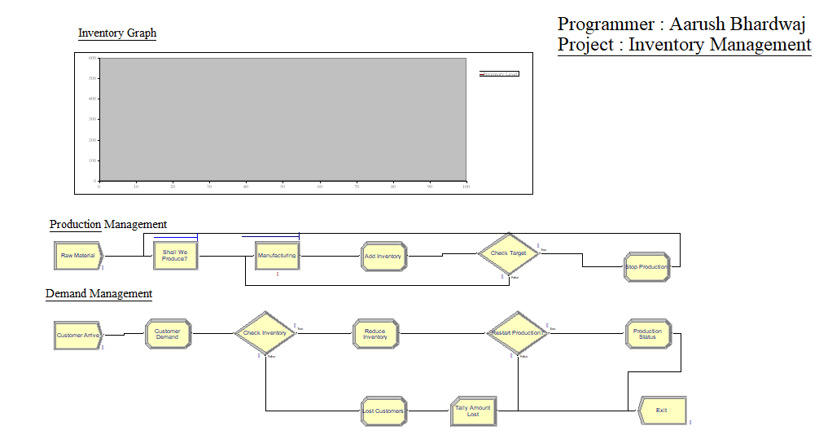

# 4.1 Entities

* **Customer** ( pre-assignment general throw away entity)

# 4.2 Resources

* **Manufacturing Cell**
  + Machine that assembled the bottles and packages them

# Expressions

* **Customer. Arrive** - The UNIF (3, 7) expression tells that the customers arrive uniformly at the time of 3 to 7 hrs.
* **Customer Demand. Demand** - The UNIF (10-50) expression tells that the range of customer’s orders are between 50 to 100.
* **Check. Inventory** - The expression inventory >= Demand checks whether we have sufficient inventory to full fill the demand. Failure fulfilling this leads to loosing of customer.
* **Restart. Production** - The expression Inventory <= Reorder Point checks whether the inventory has fallen down below the target point. If so then we restart the production.
* **Raw Material** - the expression here is set to 1. It acts as a trigger switch that turns on/off the production.
* **Shall** **we** **produce? Condition** - In this the condition is essentially an expression checks if the production value is set to 1. Production == 1
* **Manufacturing. Manufacturing Cell** - The Expression UNIF (10, 20) produces 10-20 bottles uniformly in a minute.
* **Check target. Condition** - In this expression Inventory >= Target Stock, we check if the inventory has increased above the target value.

# Variables

* **Inventory**: Starting inventory (initial value -250)
* **Target Stock** - Max. Inventory (Initial value – 500)
* **Batch Size** - Order quantity (how many am I producing at a time (5))
* **Reorder Point**- The point at which we start to manufacture again. (100)
* **Demand** - Number of orders placed by customers
* **Total Customers** - Customer arriving.
* **Demand Met** - Total orders purchased till now
* **Production** - Trigger to start (==1)/ stop (==0) production.
* **Lost** - Unfulfilled customers
* **Amount Lost** - Potential sales lost

5. Model Results

# 5.1 Key Performance Indicators

The model runs for 12 hours (600 minutes) to represent the opening hrs. of the business (10 AM - 10 PM) and is replicated for 500 hrs ( 1 month) times to represent 1 month of business operations. Entities per arrival is dictated by a uniform distribution, UNIF (3, 7) with the arrival being grouped uniformly between 3 - 7. The results are as follows:

**Entity Based**

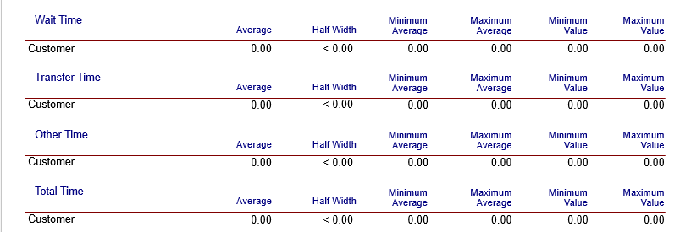

The means based confidence intervals for wait time and total time spent in process per entity type is shown above. It suggests that there are no customer in waiting and we are able to service all the customers. This is due to the fact that when the inventory drops below the target point, we immediately starts production. However, this does not mean that we are not sending the customers away (which is clear from the total customers out = 2).

**Queue Based**

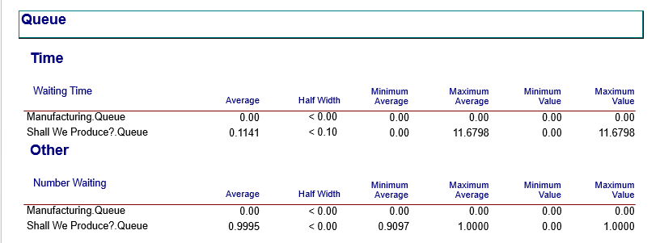

The mean based confidence intervals for waiting time per queue is shown

The report here tells us that there is no waiting in the manufacturing queue.

But we do see 1 entity in shall we produce? Queue. This is because there will always 1 variable's value (Production) in this case that will be present in the queue. The only difference is that in order to turn production on, it will have value of 1 else it will be 0.

**Resource Based**

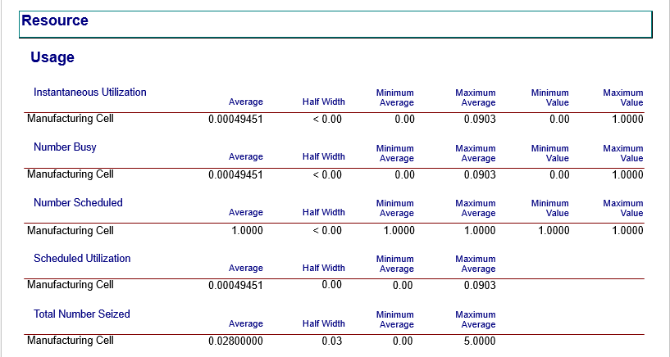

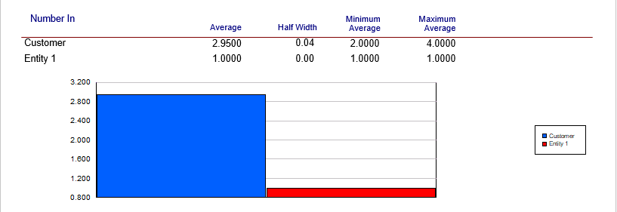

The plot here tells us that the customer entity is being used. Here customer entity means that the people who are entering are all being serviced ( well to the most part).

1. Model Conclusions

From the initial simulation results, we can conclude that the operations management systems seems to be performing well. We are able to service majority of the customers, manufacturing new products as and when required and exhaust our inventory multiple times within a single day.

However this does not mean that the system does not require improvements. There are a few things that seems odd in this model. First and foremost we are manufacturing the product multiple times or sometimes simultaneously while servicing a customer, which is not how businesses function in real life. So we need to find the best inventory size so as to avoid simultaneous manufacturing. This may mean that we need to shrink out inventory or increase it.

Another alternative that we can do is to add a new resource (machine) so that we can manufacture more in less time. So in the final section of this paper, we will experiment with these 2 scenarios to find which one will be the best solution. Here the best solution needs to be the one which does not require any additional cost to make changes to the system or even if the cost is incurred, it is negligible.

1. Alternate Model

## 6.1 Scenario I:

In this scenario, we will try to find the optimal inventory value so as to minimize our production time and customer ideal time. This can be done by 2 ways:

1. My making changes to the actual model.

A major drawback of this method is that it limits the number of scenarios that we can test at a single time. Also we stand a chance to ruin our entire model, if we lose track of the variables that are changed or were supposed to be changed.

1. Using **Process Analyzer.**

Process analyzer is a part of arena software that allows us to run multiple scenarios of a model, simultaneously. It gives us more control over the entire process and provide us with the opportunity to run multiple scenarios so that we can find the best one.

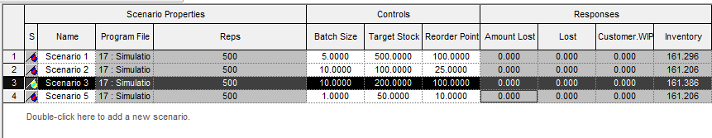

The above result from the process analyzer shows that the inventory remains same (~161) irrespective of the variation in the Batch Size, Target Stock and Reorder Point.

## 6.2 Scenario II

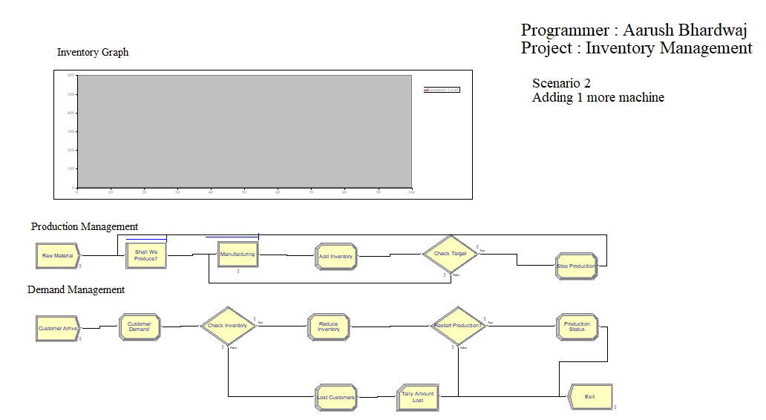

In this scenario we will be increasing the manufacturing unit by 1, i.e. we will be adding another machine to our production department.

## 6.3 Model REsults

**Entity Based**

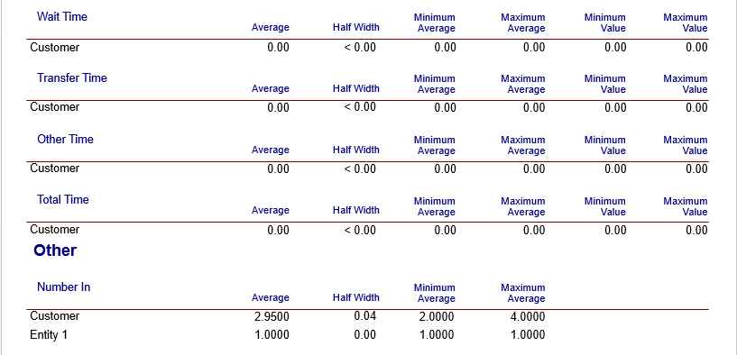

**Queue Based**

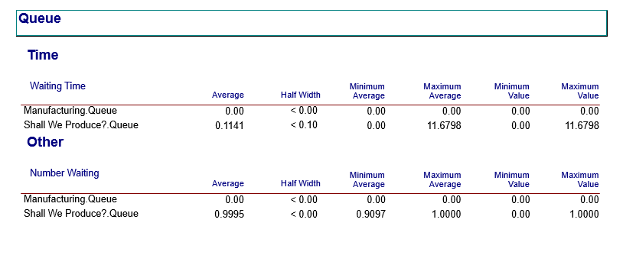

**Resource Based**

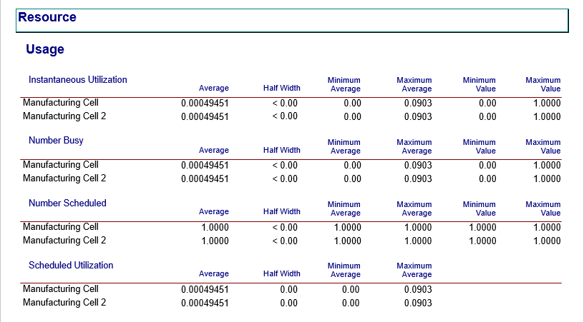

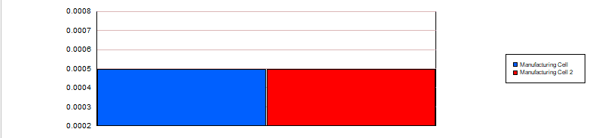

1. Final Conclusion

From the above results it is clear that adding machine 2 does not make much of a difference to the overall performance of the model. Even though the machine 2 is used in equal proportion to that of machine 1, there is no significant improvement in this.

So in my suggestion the company should continue with the existing model of demand and production as it seems to be highly efficient (negligible customer turn around, great synchronization between manufacturing and demand). But if the company still wants to increase it’s efficiency, it should start tracking half fulfilled orders (where a customer has to wait to get is order). Through that the company would further minimize its loss of customers.